PERSONAL INFORMATION | Shanker Bhattarai
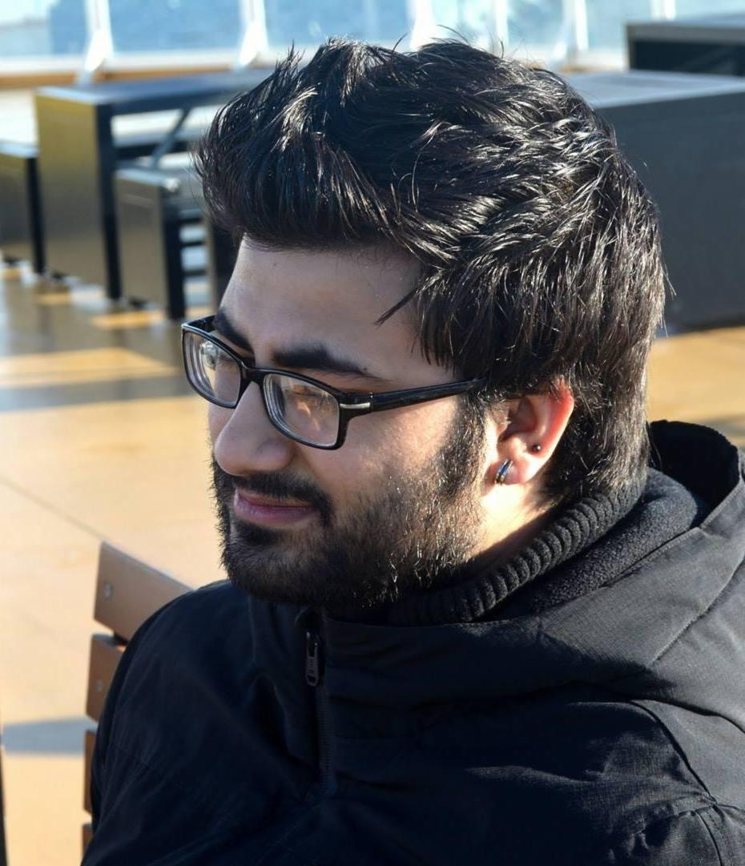 |   Yö- Kyla, 6D 11, 20540 Turku (Finland)

+358442377075

shanker.bhattarai@edu.turkuamk.fi
 | Sex Male | Date of birth 13/11/1995 | Nationality Nepalese

JOB APPLIED FOR | Wordpress Developer

WORK EXPERIENCE

01/07/2017–31/08/2017 | Junior Web Developer Intern
01/07/2017–31/08/2017 | Flavry Oy, Turku (Finland)
01/07/2017–31/08/2017 | - Creating & Developing new web pages using HTML and CSS.  - User testing & feedback giving to current pages.

04/01/2017–31/06/2017 | Data entry operator
04/01/2017–31/06/2017 | Flavry Oy, Turku (Finland)
04/01/2017–31/06/2017 | - Data collecting from different sources & online materials  - Data handling in already-created database

04/05/2012–31/10/2013 | Pre-primary education teaching professional
04/05/2012–31/10/2013 | Supreme English School, Kathmandu (Nepal)

29/12/2016–Present | Supervisor at Ship Cleaning.
29/12/2016–Present | Sol Palvelut Oy, Turku (Finland)
29/12/2016–Present | - Team leader at Ship Cleaning SOL Palvelut Oy (Viking Line).  - Cleaner at hotels and other establishments.

EDUCATION AND TRAINING

01/09/2014–Present | Bachelors of Engineering in Information Technology
01/09/2014–Present | Turku University of Applied Sciences, Turku (Finland)
01/09/2014–Present | - Final year student  - Looking for Internship & Practical Training in the field of Embedded Computing Software Development

PERSONAL SKILLS

Mother tongue(s) | Nepali
Foreign language(s) | UNDERSTANDING |  | SPEAKING |  | WRITING
Foreign language(s) | Listening | Reading | Spoken interaction | Spoken production
English | C1 | C1 | C1 | C1
Hindi | C1 | C1 | C1 | C1 | C1
Finnish | B1 | A2 | A2 | A2 | A1
Levels: A1 and A2: Basic user - B1 and B2: Independent user - C1 and C2: Proficient user
Common European Framework of Reference for Languages

Communication skills | -Good communication skills gained through working as a Team Leader in Sol Palvelut Oy;  -Great contact skills with children working as a part time teacher;  - Gaining multi-cultural understanding and international connections through Flavry Oy.

Organisational / managerial skills | - Excellent team leading skills;  - Excellent skills of people management & time management as a team leader;  - Work-oriented & co-worker friendly attitudes;  - Self-motivated and self-discipline.

Job-related skills | - Elementary knowledge on web development skills (HTML, CSS, PHP);  - Elementary Programming languages, (C, C++);  - Advanced Programming in embedded computing system in arduino environment.

Digital skills | SELF-ASSESSMENT
Digital skills | Information processing | Communication | Content creation | Safety | Problem solving
 | Independent user | Independent user | Independent user | Independent user | Independent user
 | Digital skills - Self-assessment grid

Other skills | - Excellent Public Speaking & presentation skills (ICT showroom).  - Negotiation skills (at small scale).  - IELTS: 7.0 (READING 8.0) (2013)  - International Tutor Program (member) (2015)  - Finnish Red Cross Org: fundraising for Nepali earthquake (Apr 2015)
